TUGAS PRAKTIKUM 5
Kevin Ramadhan
4519210107
Desain Web B

Screenshots file HTML
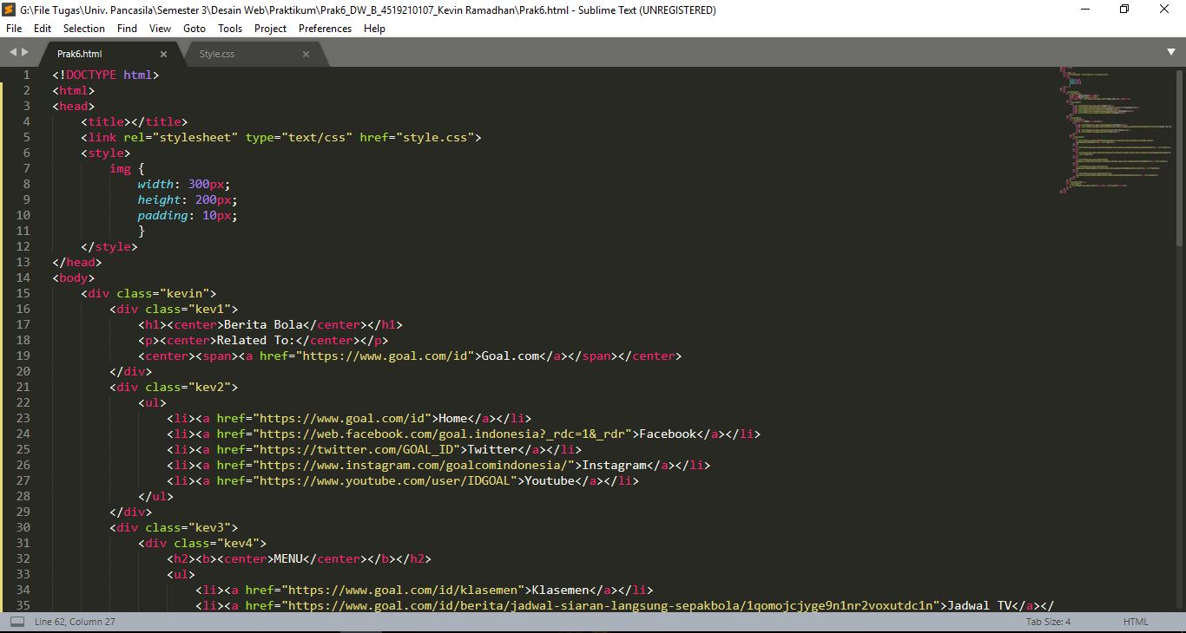
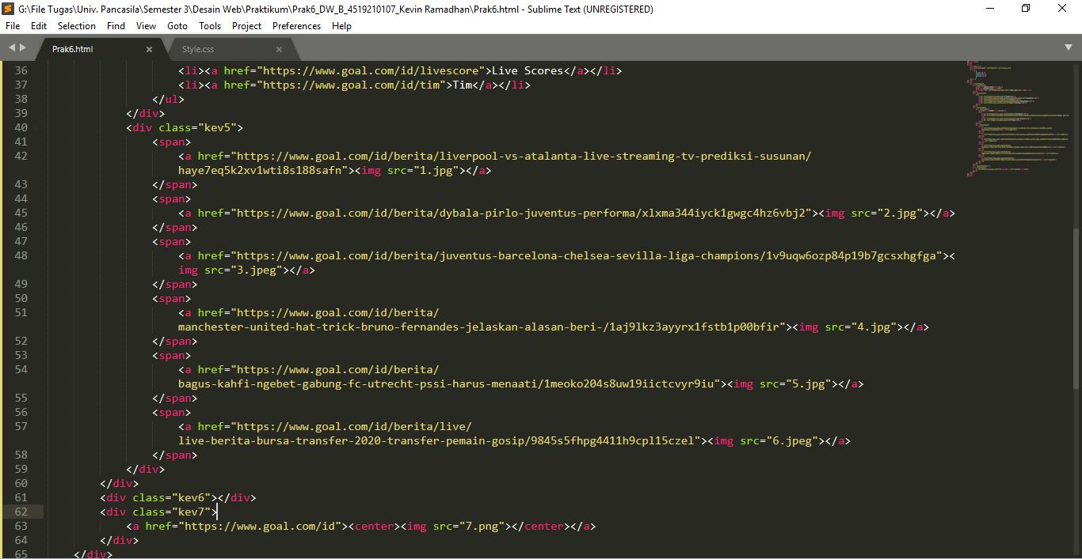

Screenshots file CSS
